‘’A SINGLE LAMP CAN LIGHT UP A ROOM, JUST LIKE A SINGLE ACT OF KINDENESS CAN LIGHT UP SOMEONE’S LIFE.’’

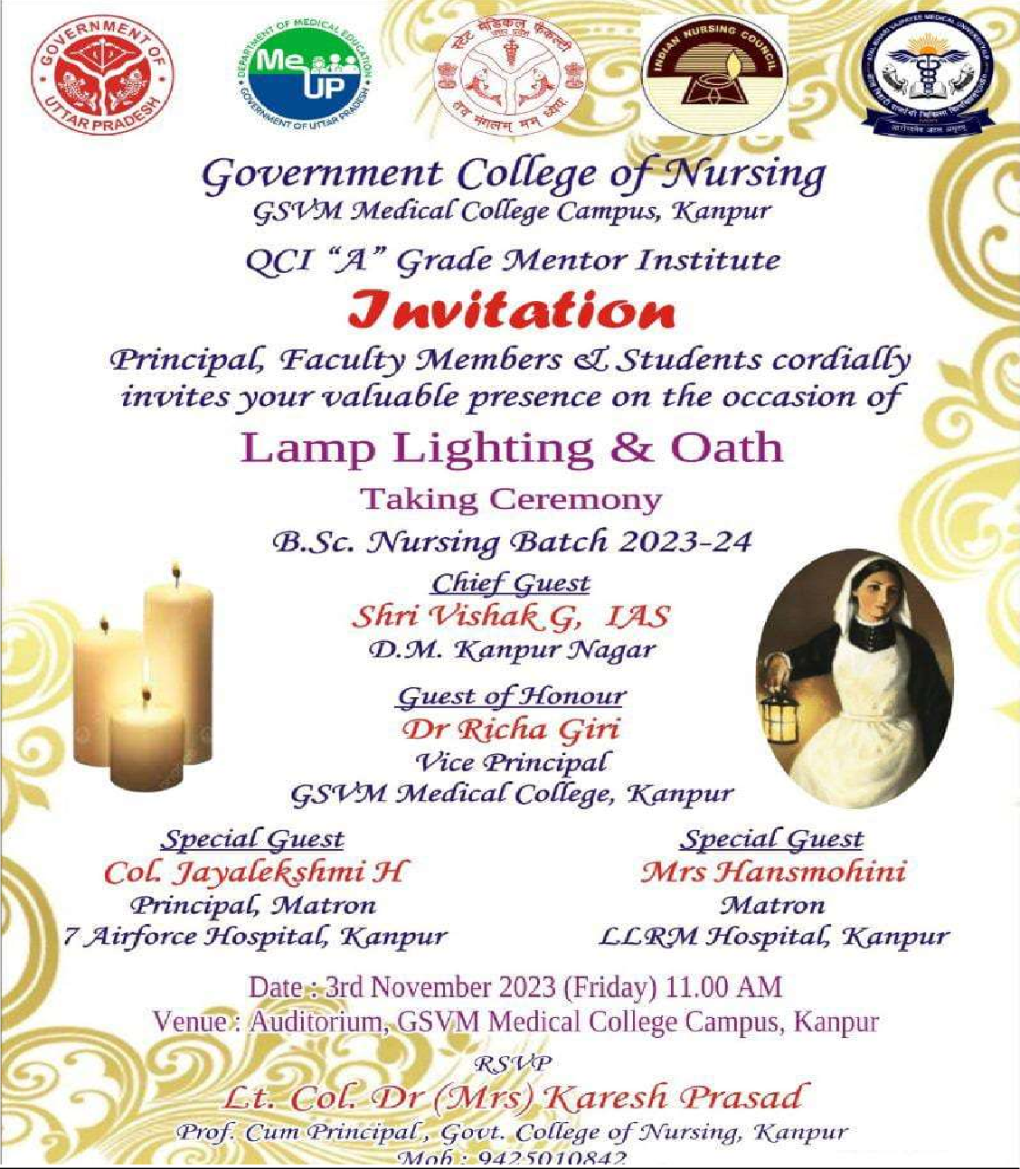

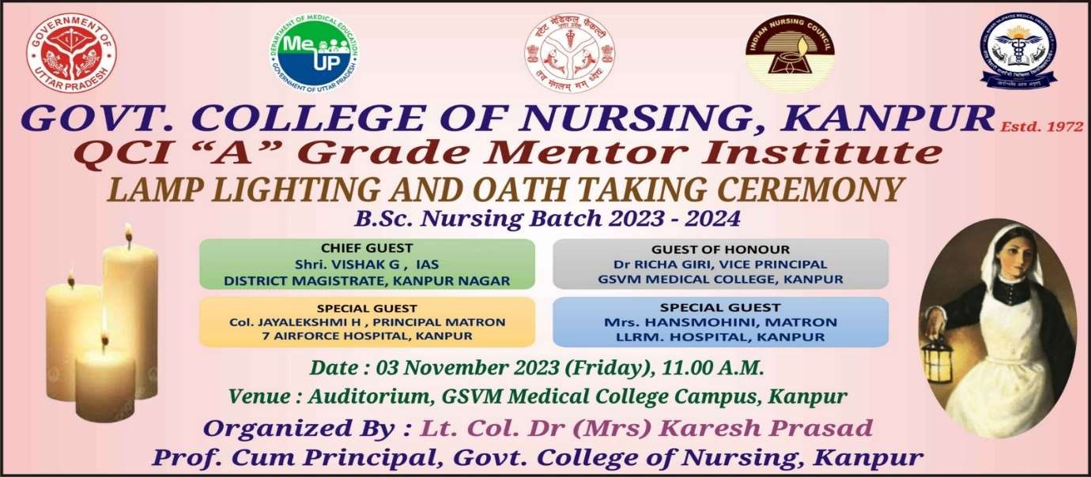

The lamp Lighting ceremony is an auspicious occasion in every nurse's life with reverence to Florence Nightingale- the lady with lamp. The Lamp lighting ceremony formally recognizes the student’s entry into the nursing profession. Nursing is the only profession that follows lamp lighting ceremony. Here light not only symbolizes knowledge which removes ignorance and is a lasting wealth by which lots could be achieved but it also signifies the enlightenment, experience, hope, love, comfort, and positivity, driving away from the negativity that darkens everything. The oath taken by every nursing professional signifies the discharge of their duties with complete honesty, and integrity and without any discrimination.

Objectives of the Programme
- To formally induct the students into professional nursing.
- To aware the students towards their role and values in professional practice.
- To motivate the student nurses by providing a sense of achievement.
- To establish an individualized professional development and continued education within the nursing profession as a new graduate.

Programme Schedule

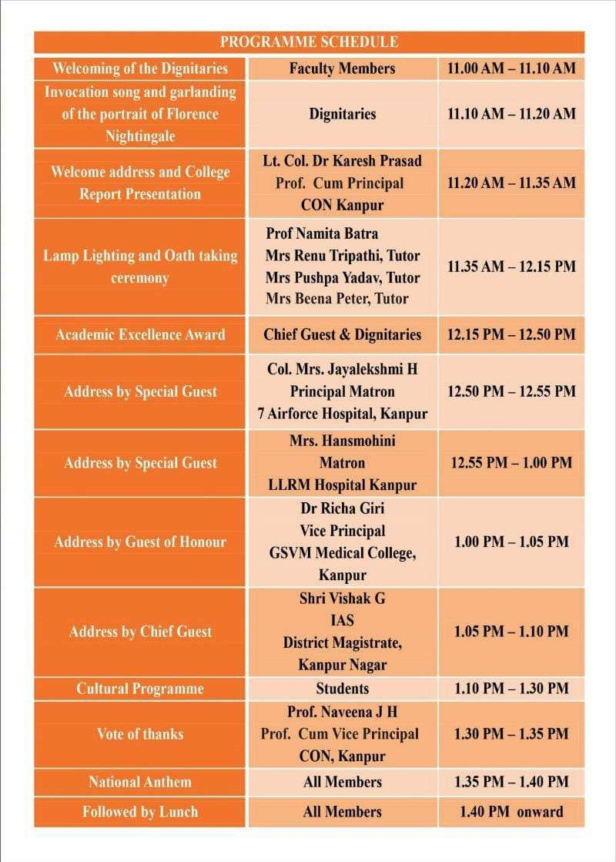

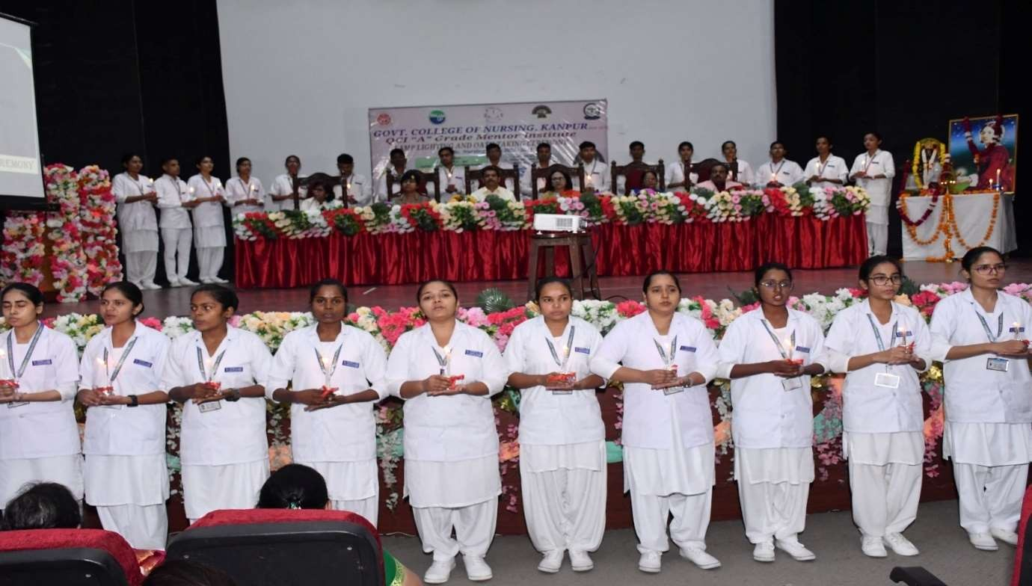

The ‘Lamp Lighting & Oath Taking Ceremony “of B.Sc. Nursing students of College of Nursing Kanpur was held on Friday 3rd November 2023 at 11:00am in Auditorium of GSVM Medical College Campus Kanpur under the able leadership of Lt. Col Dr. Karesh Prasad, Professor cum Principal, College of Nursing, Kanpur.
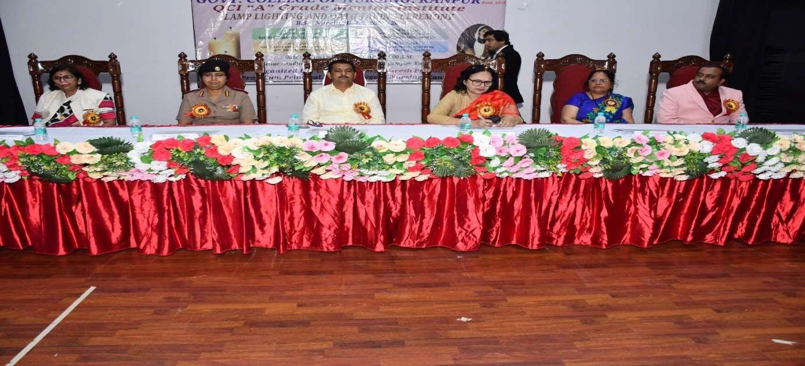
The programme started with welcoming the guest. The programme was graced by Chief Guest Rtn. Prem Kumar Tripati, MD Anushree Infrastructure, Ex. President & Ex. Secretary, Rotatory club, Vinayaka, Guest of Honor Dr. Richa Giri, Vice Principal GSVM Medical College Kanpur, Special Guest Col. Mrs. Jayalekshmi H, Principal Matron, 7 Airforce Hospital, Kanpur, Special Guest Mrs. Hansmohini, Matron, LLRM Hospital, Kanpur, Lt. Col. Dr Karesh Prasad Professor cum Principal Govt. College of Nursing, Kanpur.

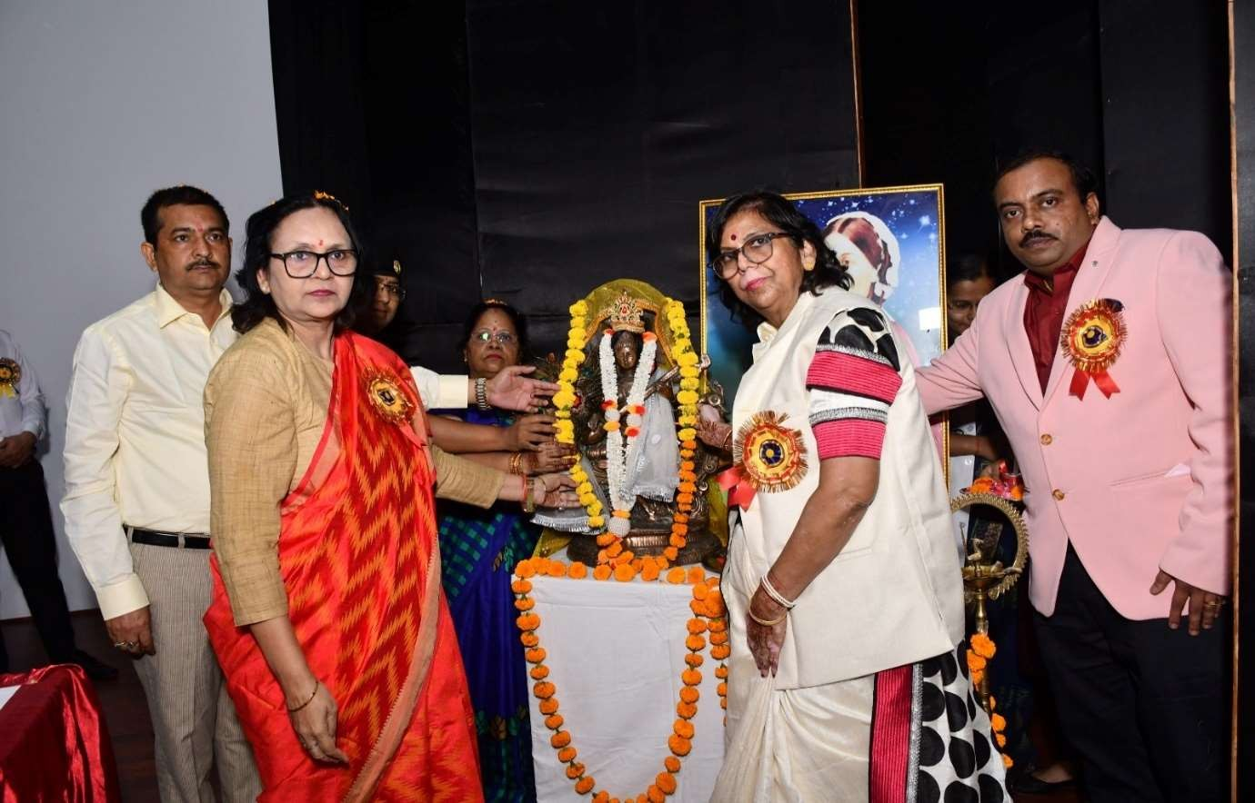

On the dais the programme was inaugurated by lighting of traditional lamp with auspicious hands of dignitaries and garlanding of the portrait of Florence Nightingale -Lady with the lamp by the dignitaries.
Lt. Col. Dr. Karesh Prasad Professor cum Principal Govt. College of Nursing, Kanpur. welcomed the guests and presented the annual report of the college where she has an account of achievements made by the institute and assured the parents of students that their children are in safe hands to mold and create their bright carrier in nursing profession.
The core of the programme was passing of lights to the B.sc Nursing 1st year students by Honorable Principal mam followed by the teaching faculties Prof. Namita Batra, (Professor) Mrs. Renu Tripathi (tutor), Mrs. Pushpa Yadav (tutor) and Mrs. Beena Peter (Tutor)
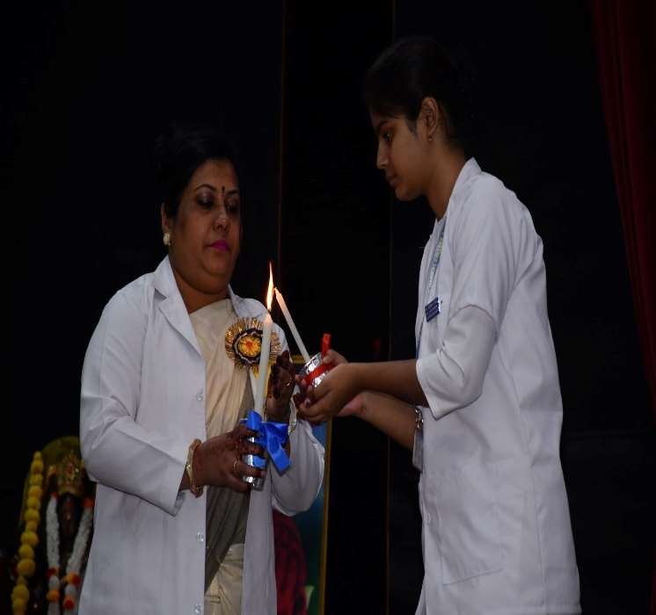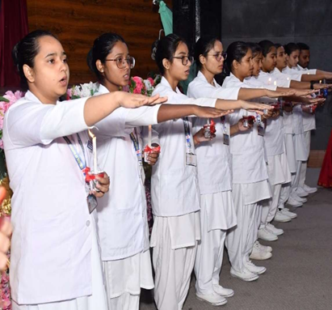

.

Florence Nightingale oath was led to the students by Dr. Ram Kumar Gupta, Assistant professor, Department of Mental Health Nursing. The students promised to fulfill their duties & practice their profession faithfully and confidently.

Taking the programme forward, the Academic In charge Prof. Namita Batra, College of Nursing Kanpur, announced the names of meritorious students for certificates and medals for their excellent performance in academics. Awards were distributed by the dignitaries among the students who excelled in academics.

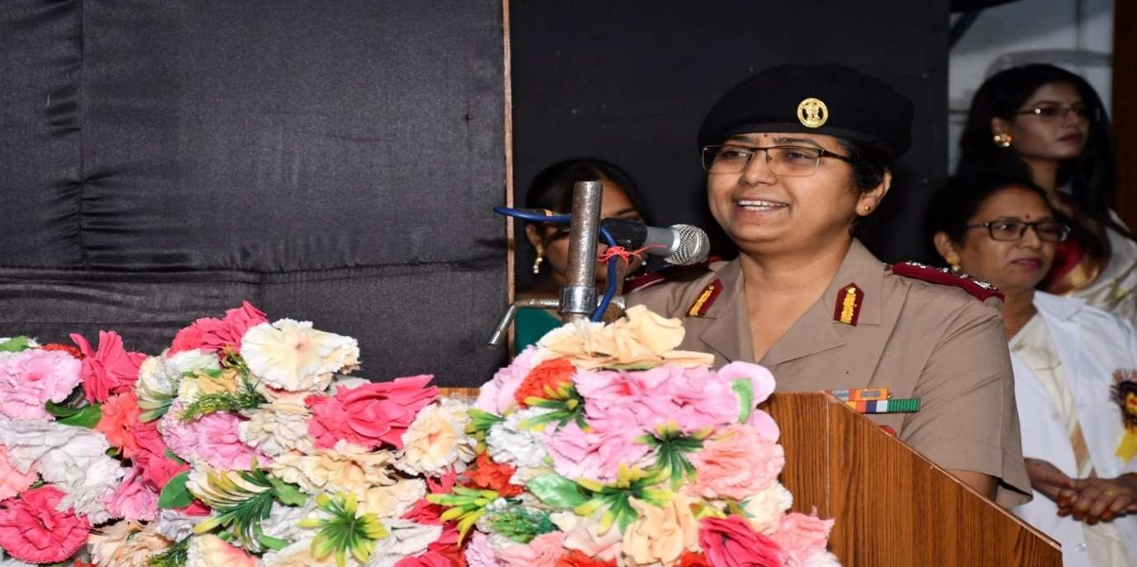
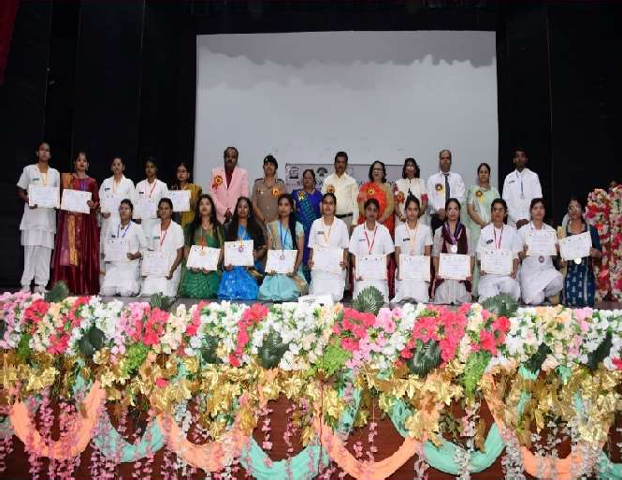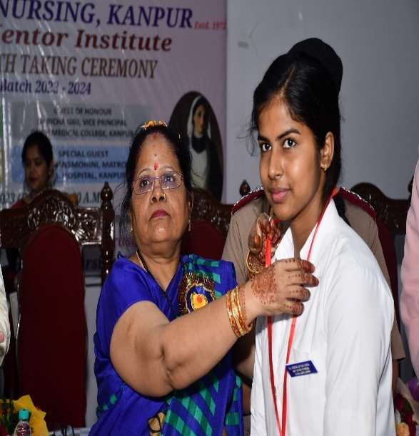

The programme was continued with addressing of chief guests and special guests. Col. Mrs. Jayalekshmi H, Principal Matron,7 Airforce Hospital, Kanpur, Special Guest has enlightened the students on the significance of lamp lighting and oath taking in nursing profession and address that an educated nurse must also possess spiritual qualities in order to serve humanity by giving the patient remedial care.

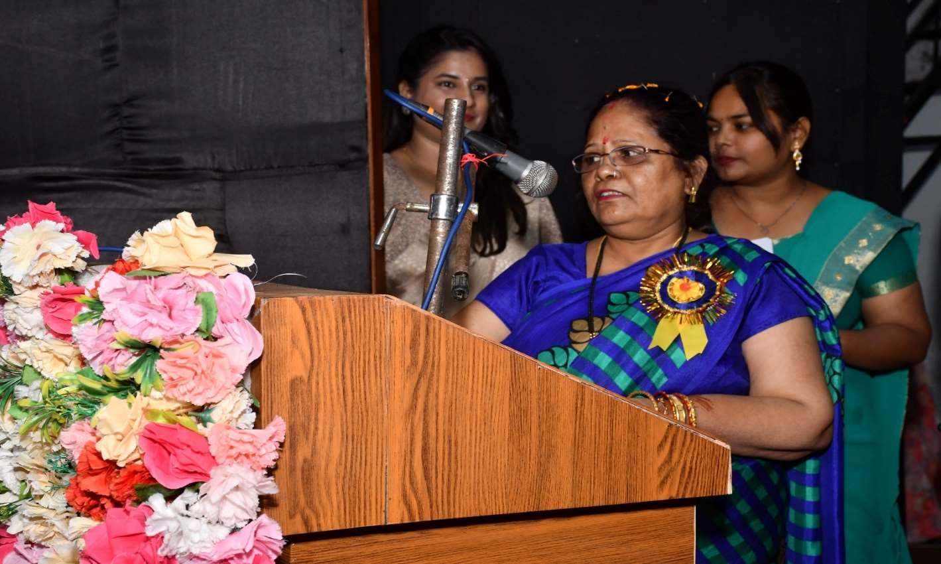
Mrs. Hansmohini Matron LLRM Hospital Kanpur, Special Guest highlighted that the present healthcare workforce demands nurses to be more logical on how they can rise to take their profession.
DR. Richa Giri vice principal GSVM Medical college Kanpur, Guest of Honor in her presidential address she congratulated and blessed the newly elected students and said to perform their duties and responsibilities sincerely and with full dedication.
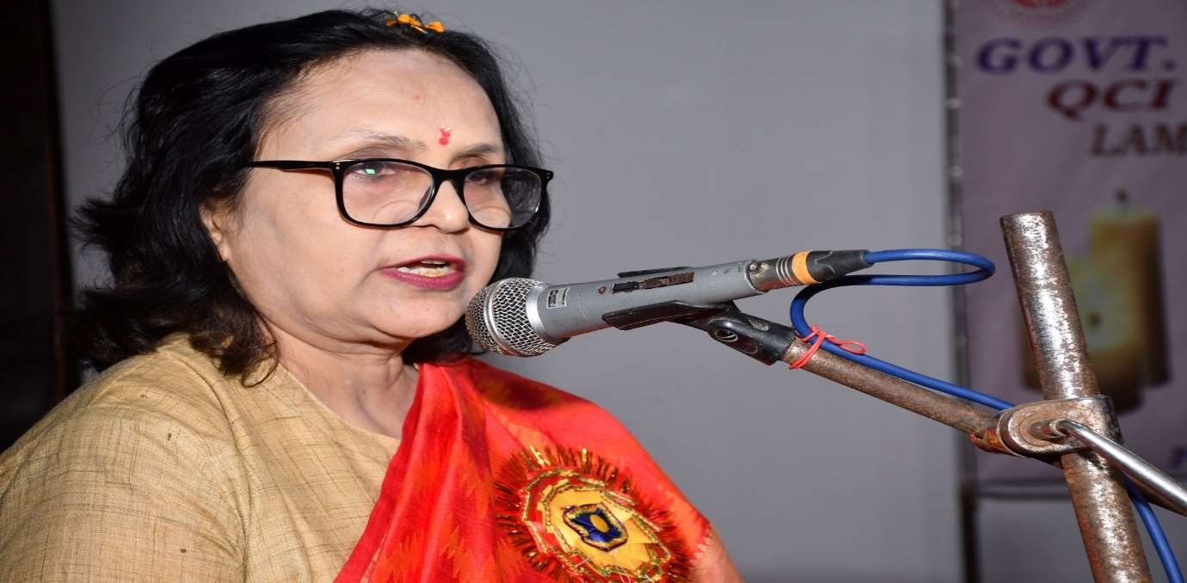

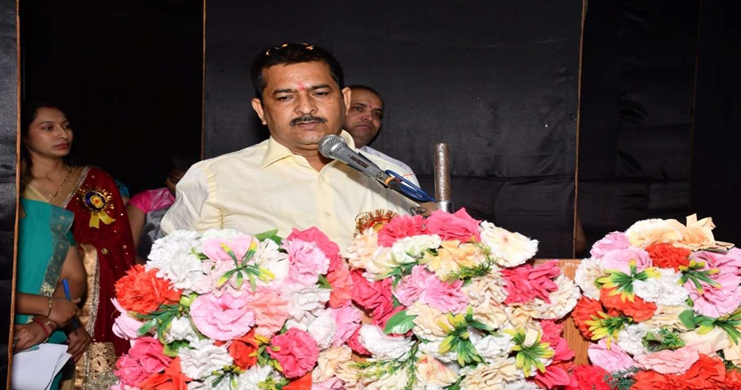
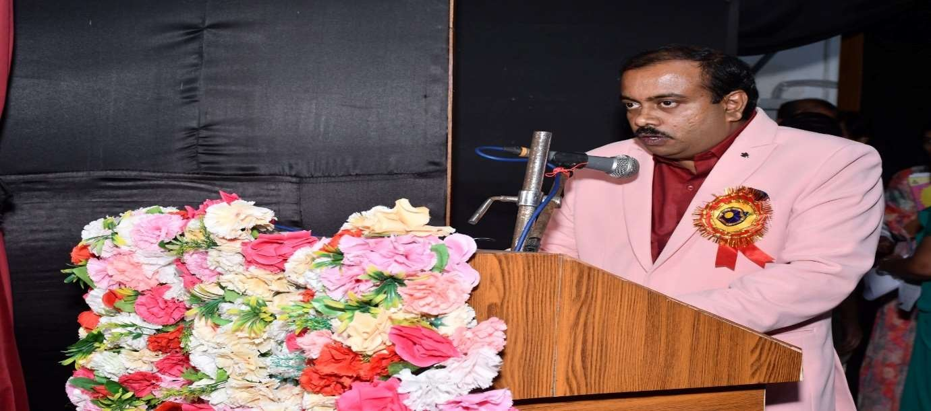
Rtn. Prem Kumar Tripati MD Anushree Infrastructure Ex. President & Ex. Secretary, Rotatory Club, Vinayaka, Chief Guest addresses the responsibilities and value of nurses in the society.

The programme was concluded at 1:30 pm by Vote of Thanks conveyed on behalf of College Of Nursing, Kanpur by Prof. Naveena J.H, Vice Principal, College Of Nursing, Kanpur.
Followed by Lamp lighting and oath taking ceremony, students were showcasing their talents through the brief cultural events of Ganesh Vandana, Fusion dance performances and songs.

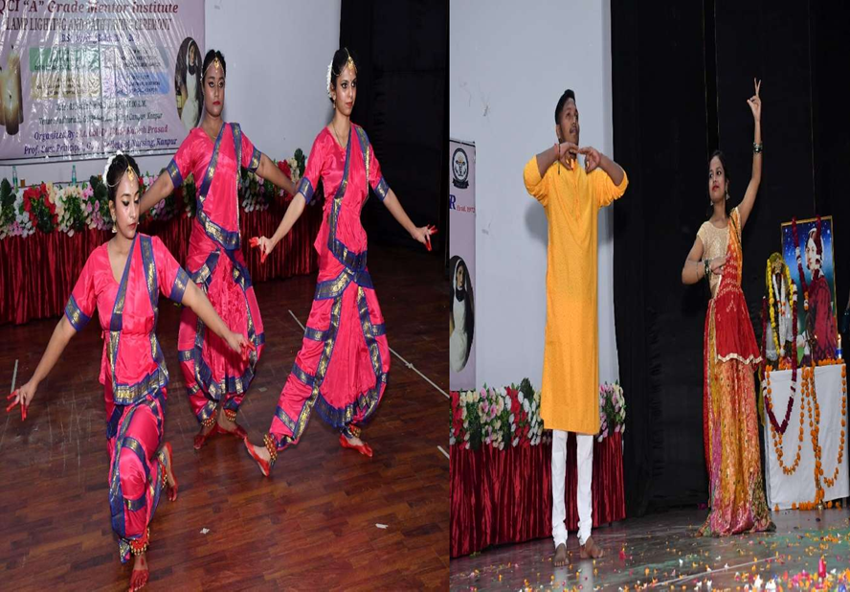

The programme ends with the National Anthem. Then all dignitaries and faculty joined a photo session followed by lunch.

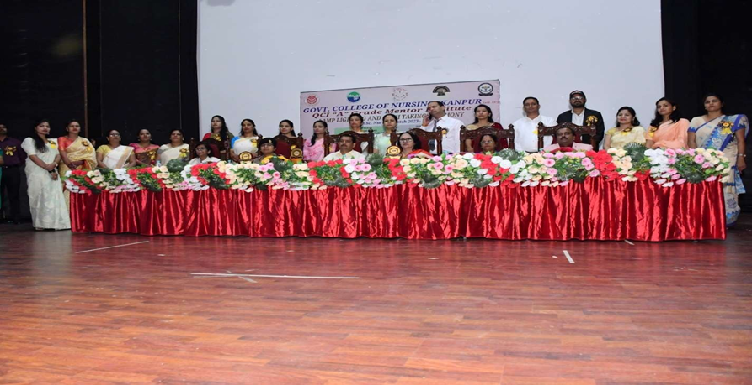

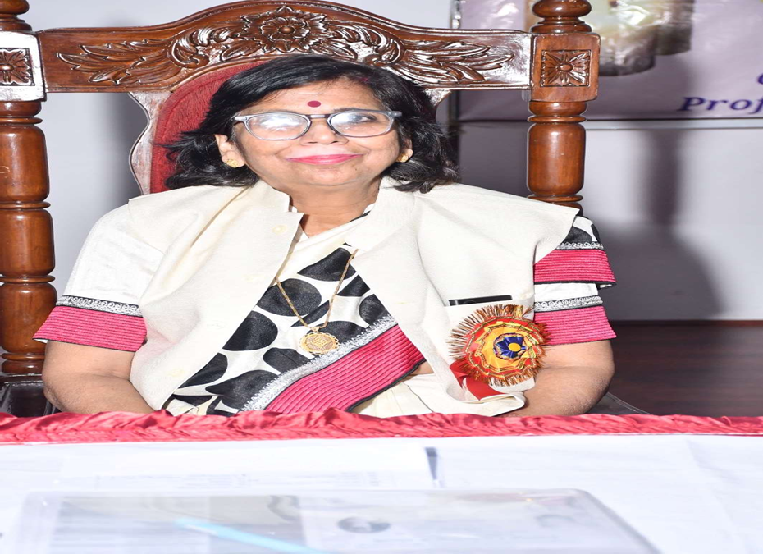

The programme was successfully organized by the support and guidance of Lt. Col. Dr. Karesh Prasad Professor cum Principal Govt. College of Nursing, Kanpur.

